November 1, 2023

Dear Chair and Members of the Arts and Sciences Curriculum Committee:

On September 13, 2023, the Arts and Humanities Subcommittee 2 reviewed a request from the Department of Art to create a new undergraduate minor in Animation.

The proposed minor has the goal of drawing together existing coursework available in various departments in meaningful ways to allow undergraduates to hone their skillset in animation, a “complex, time-based art form, mixing drawing, 3D modeling, motion, and storytelling.” Harnessing the university’s “abundant animation resources and offerings”, the minor will provide students with clear pathways to deepen their knowledge and skills in animation in a way that is recognizable on their transcript.

The 15-credit hour minor includes the following:
- 1 (3 credit-hours) Foundations course offering an introduction to time-based media
- 2-3 core courses (totaling 6-9 credit hours) focused on animation techniques
- 1-2 elective courses (totaling 3-6 credit-hours) that allow students to develop their interest in particular sub-areas or to supplement their technical skills
A&H Subcommittee 2 voted unanimously to approve the request with three contingencies and two recommendations. Those items have since been addressed by the unit and the proposal is now advanced to the ASCC with a motion to approve.

Sincerely,
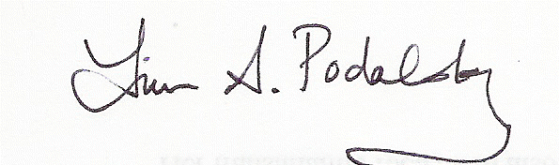
Laura A. Podalsky
Professor
Department of Spanish and Portuguese
Chair, ASCC A&H Subcommittee 2

